[(219) How a chef app functions using reactive native, and android studio - YouTube](https://www.youtube.com/watch?v=5vAL_T5P4us)

[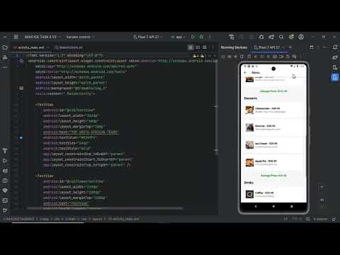](https://www.youtube.com/watch?v=5vAL_T5P4us)